Internship project report:

Project Title
“Network Packet Sniffer using Python (Scapy Library)”

Submitted By:
Khadija Farooq

Introduction
In modern computer networks, data is continuously transmitted in the form of packets. These packets contain important information such as source and destination IP addresses, protocol types, port numbers, and payload data.
The purpose of this project is to develop a simple network packet sniffer using Python and the Scapy library. The tool captures live network traffic and displays packet-level details in real time. It also stores captured data in a log file for further analysis.
This project helps in understanding how network communication works at a low level and provides an introduction to cybersecurity and network traffic monitoring.

Objectives
The main objectives of this project are:
- To understand the structure of network packets
- To capture live network traffic using Python
- To analyze IP, TCP, UDP, and ICMP protocols
- To extract key packet information such as IP addresses and ports
- To store network data for future analysis
- To gain practical experience in network security concepts

Tools and Technologies Used
The following tools and technologies were used:
Programming Language:
- Python 3
Library:
- Scapy (for packet capturing and analysis)
Built-in Modules:
- datetime (for timestamps)
Operating System:
- Windows (with administrator privileges)

System Requirements
Hardware:
- Minimum 4 GB RAM
- Any modern processor (Intel/AMD)
Software:
- Python 3.x installed
- Scapy library installed using pip
- Npcap installed for packet capturing support on Windows
- VS Code or any Python IDE

System Design and Working
The system works in the following steps:
Step 1: Packet Capture
The Scapy library uses the sniff() function to capture live network packets from the active network interface.
Step 2: Packet Processing
Each captured packet is passed to a callback function where it is analyzed.
Step 3: Data Extraction
If the packet contains an IP layer, the following information is extracted:
- Source IP address
- Destination IP address
- Protocol type
If the packet contains TCP or UDP layers, additional information is extracted:
- Source port number
- Destination port number
If raw data is present, a small portion of payload data is displayed for readability.
Step 4: Logging System
All extracted packet information is:
- Printed on the console in real time
- Saved into a file named log.txt

Project Features
- Real-time network packet capture
- Identification of network protocols (TCP, UDP, ICMP)
- Extraction of source and destination IP addresses
- Extraction of port numbers
- Timestamp for each packet
- Packet numbering system for tracking
- Payload preview for analysis
- Automatic logging into a text file

Implementation Details
The project is implemented using Python with Scapy’s packet sniffing capabilities.
Core Function:
- sniff() is used to capture packets
- Callback function processes each packet individually
Key Logic:
- Check if packet has IP layer
- Extract IP information
- Check transport layer (TCP/UDP)
- Extract port information
- Store output in log file

Output Description
The program produces two types of output:
1. Console Output
Displays real-time packet information such as:
- Packet number
- Timestamp
- Source IP
- Destination IP
- Protocol type
- Port numbers
- Payload (partial)
2. Log File Output
All captured packet data is stored in:
- log.txt
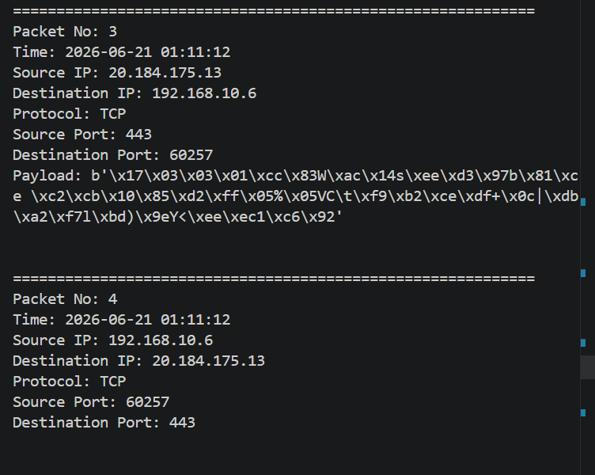
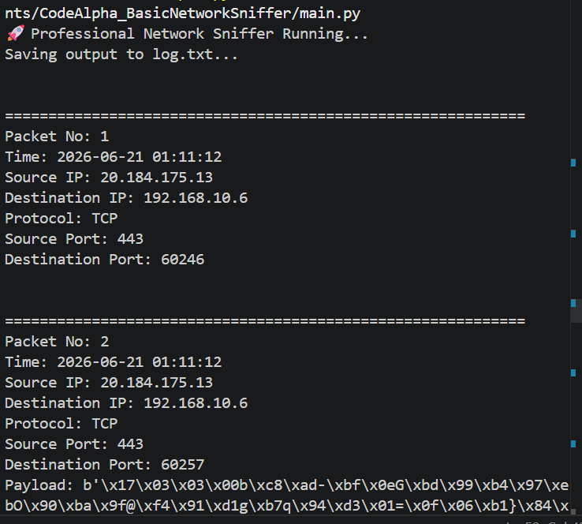
This allows offline analysis of network traffic.

Example Output
Packet No: 1
Time: 2026-06-21 10:30:45
Source IP: 192.168.1.5
Destination IP: 142.250.190.14
Protocol: TCP
Source Port: 52341
Destination Port: 443
Payload: b'Encrypted data stream...'

Challenges Faced
During development, the following challenges were encountered:
- Windows required Npcap installation for packet capture
- Encrypted HTTPS traffic could not be decoded due to security protocols
- Raw packet data was difficult to interpret without filtering
- Administrator privileges were required to run the sniffer

Learning Outcomes
After completing this project, the following skills and concepts were learned:
- Understanding of network packet structure
- Working of IP, TCP, UDP protocols
- Real-time packet analysis using Python
- Basics of cybersecurity monitoring tools
- File handling for logging data
- Practical use of Scapy library

Limitations
- Cannot decrypt HTTPS encrypted payloads
- Requires administrator access to run
- Limited to local network interface traffic
- No graphical user interface (CLI-based tool only)

Future Improvements
This project can be enhanced further by adding:
- Graphical User Interface (GUI) for better visualization
- Packet filtering system (HTTP, DNS, etc.)
- Export logs in CSV or JSON format
- Real-time dashboard for monitoring traffic
- Alert system for suspicious activity detection
- Machine learning-based traffic analysis
Conclusion
This project successfully demonstrates the basics of network packet capturing and analysis using Python. It provides practical knowledge of how data travels across a network and how different protocols operate.
The project also serves as an introduction to cybersecurity and network monitoring tools. With further enhancements, it can be developed into a more advanced network analysis system similar to professional tools like Wireshark.
Author
Khadija
Status: Intern
GitHub Repository:
https://github.com/khadija656/codealpha-network-packet-sniffe

